Week 3 – 2:
--Coding-C-Language Features-Optional.
ROLL NO.:240701211
Name: Jeevan B

Q1)Write a program that determines the name of a shape from its number of sides. Read the
number of sides from the user and then report the appropriate name as part of a
meaningful message. Your program should support shapes with anywhere from 3 up to
(and including) 10 sides. If a number of sides outside of this range is entered then your
program should display an appropriate error message.
Sample Input 1
3
Sample Output 1
Triangle
Sample Input 2
7
Sample Output 2
Heptagon
Sample Input 3
11
Sample Output 3
The number of sides is not supported.

Code :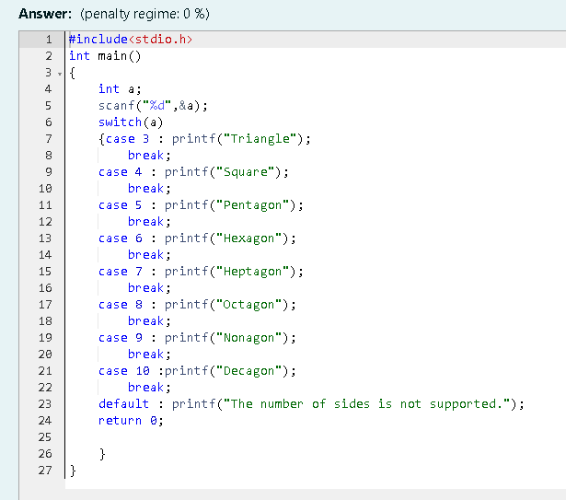
OUTPUT:

